Microprocessor 8086

8086 contains two independent functional units:
- Bus Interface Unit (BIU)
- Execution Unit (EU).

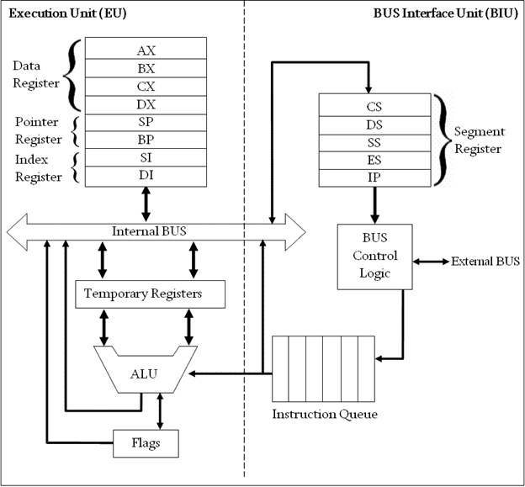
Block Diagram of Intel 8086 Microprocessor (8086 Architecture)

Bus Interface Unit (BIU)
The segment registers, instruction pointer and 6-byte instruction queue are associated with the bus interface unit (BIU).
The BIU:
- Handles transfer of data and addresses,
- Fetches instruction codes, stores fetched instruction codes in first-in-first-out register set called a queue,
- Reads data from memory and I/O devices,
- Writes data to memory and I/O devices,
- The EU tells the BIU from where to fetch instructions or where to read data.
It has the following functional parts:
- Instruction Queue: When EU executes instructions (FIFO), The BIU gets 6-bytes of the next instruction and stores them in the instruction queue and this process is known as instruction pre fetch.
- This process increases the speed of the processor.
Segment Registers: A segment register contains the addresses of instructions and data in memory which are used by the processor to access memory locations.
- It points to the starting address of a memory segment currently being used.
- There are 4 segment registers (16 bit) in 8086 as given below:
  - Code Segment Register (CS): Code segment of the memory holds instruction codes of a program.
  - Data Segment Register (DS): Points to the current data segment; The data, variables and constants given in the program are held in the data segment of the memory.
  - Stack Segment Register (SS): Stack segment holds addresses and data of subroutines.
It also holds the contents of registers and memory locations given in PUSH instruction.
  - Extra Segment Register (ES): Extra segment holds the destination addresses of some data of certain string instructions.

- Instruction Pointer (IP): Acts as a program counter.
- indicates to the address of the next instruction to be executed.

Execution Unit (EU)
- The EU receives opcode of an instruction from the queue, decodes it and then executes it.
- While Execution, unit decodes or executes an instruction, then the BIU fetches instruction codes from the memory and stores them in the queue.
- The BIU and EU operate in parallel independently. This makes processing faster.

General Purpose Registers: There are four 16-bit general purpose registers:
AX (Accumulator Register),
BX (Base Register),
CX (Counter Register)
DX(Data Register)

Each of these 16-bit registers are further subdivided into 8-bit registers as shown below:
16-bit registers | 8-bit high-order registers | 8-bit low-order registers
AX | AH | AL
BX | BH | BL
CX | CH | CL
DX | DH | DL

Accumulator Register (AX)
- Consists of two 8-bit registers AL and AH, which can be combined together and used as a 16-bit register AX.
- Stores the 16-bit results of arithmetic and logic operations
- AL contains the high-order byte
- AH contains the high-order byte.

Base Register (BX)
- Consists of two 8-bit registers BL and BH, which can be combined together and used as a 16-bit register BX.
- Used to hold base value in base addressing mode to access memory data
Counter Register (CX)
- Consists of two 8-bit registers CL and CH, which can be combined together and used as a 16-bit register CX.
- Used to hold the count value in SHIFT, ROTATE and LOOP instructions

Data Register (DX)
- Consists of two 8-bit registers DL and DH, which can be combined together and used as a 16-bit register DX.
- Used to hold data for multiplication and division operations

Register: The following four registers are in the group of pointer and index registers:
- Stack Pointer (SP)
- Base Pointer (BP)
- Source Index (SI)
- Destination Index (DI)
Stack Pointer (SP)
- SP and BP are used to access data in the stack segment.
- SP contents are automatically updated (incremented/decremented) due to execution of a POP or PUSH instruction.
- Used to hold the offset address of top stack memory

Base Pointer (BP)
- BP contains an offset address in the current SS, which is used by instructions utilizing the based addressing mode.
- Used to hold the base value in base addressing using SS register to access data from memory
Source Index (SI)
- SI is the Source Index Register.
- Which is used to point to memory locations in the data segment addressed by DS.
- By increment the contents of SI one can easily access consecutive memory locations
- Used to hold index value of source operand (data) for string instruction.

Destination Index (DI)
- DI is the Destination Index register performs the same function as SI.
- Used to hold the index value of destination operand (data) for string operations

ALU: It handles all arithmetic and logical operations. Such as addition, subtraction, multiplication, division, AND, OR, NOT operations.
- Flag Register: It is a 16?bit register which exactly behaves like a flip-flop, means it changes states according to the result stored in the accumulator. It has 9 flags and they are divided into 2 groups i.e. conditional and control flags.

- Conditional Flags: This flag represents the result of the last arithmetic or logical instruction executed. Conditional flags are:
  - Carry Flag
  - Auxiliary Flag
  - Parity Flag
  - Zero Flag
  - Sign Flag
  - Overflow Flag

- Control Flags: It controls the operations of the execution unit. Control flags are:
  - Trap Flag
  - Interrupt Flag
  - Direction Flag

Flag register of 8086 microprocessor

- The Flag register is a Special Purpose Register.
- Depending upon the value of result after any arithmetic or logical operation the flag bits become set (1) or reset (0).
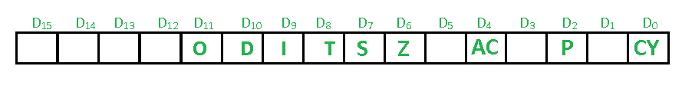
- There are total 9 flags in 8086 and the flag register is divided into two types:

(a) Status Flags
- There are 6 flag registers in 8086 microprocessor which become set(1) or reset(0) depending upon condition after either 8-bit or 16-bit operation. These flags are conditional/status flags.

- Carry Flag (CY)
CY flag is set=1 whenever there is a in case of addition or borrow out of t he MSB.

- Parity Flag (P)
This is even parity flag. When result has even number of 1’s, then P=1, otherwise 0 for odd number of 1s.

- Auxiliary Cary Flag (AC)
When some arithmetic operations generates carry after the lower half and sends it to upper half, the AC=1

- Zero Flag (Z)
If the total register is zero, then only the Z flag is set.

- Sign Flag (S)
After any operation if MSB=1, then it indicates that the number is negative. And this flag is set to 1

- Overflow Flag (O)
The overflow flag is set to 1 when the result of a signed operation is too large to fit.

(b) Control Flags
- The control flags enable or disable certain operations of the microprocessor.
- There are 3 control flags in 8086 microprocessor and these are:

- Directional Flag (D)
- This flag is used to string related operations
- If D=1 then access the string data from higher memory address to lower memory address.
- If D=0 then access the string data from lower memory address to higher memory address.

- Interrupt Flag (I)
  - This flag is for interrupts.
- If I=1 then the microprocessor will recognize interrupt requests from the peripherals.
- If I=0 then the microprocessor will not recognize any interrupt requests and will ignore them.

- Trap Flag (T)
  - This flag is used for on-chip debugging.
  - If T=1 then It will work in single step mode for debugging. After each instruction, one internal interrupt is generated. It helps to execute some program instruction by instruction.
  - If T=0 then no function is performed.

Physical Memory Organization

- 1MB memory is physically organized as an odd bank and 512 KB as an even bank.
- Byte data with an even address is transferred on D7-D0
- Byte data with an odd address is transferred on D15-D8
- FFFF0h to FFFFFh are reserved for initialization of program & I/O process,
- 000000h to 003FFh are reserved for interrupt vector table.
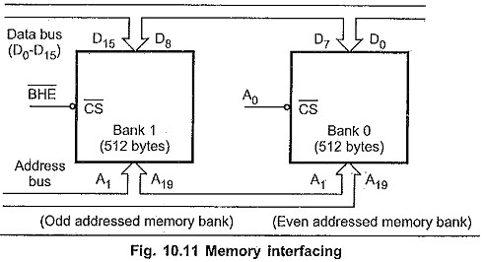

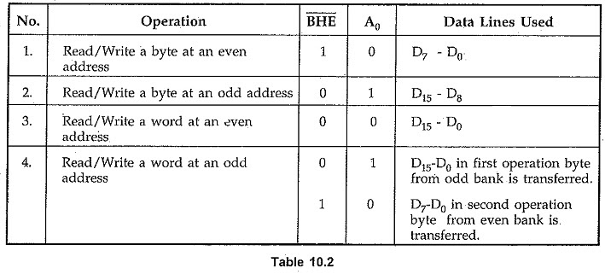

Addressing Nodes

- Every instruction of a program has to operate on a data.
- The different ways in which a source operand is denoted in an instruction are known as addressing modes

- Register Addressing
In this type of addressing mode the instruction will specify the name of the register which holds the data to be operated by the instruction.

Example:

MOV CL, DH

The content of 8-bit register DH is moved to another 8-bit register CL

(CL) ← (DH)

- Immediate Addressing
In this type of addressing mode an 8-bit or 16-bit data is specified as part of the instruction.

MOV DL, 08H

The 8-bit data (08_{H}) given in the instruction is moved to DL

(DL) ← 08

MOV AX, 1234H

The 16-bit data (1234H) given in the instruction is moved to AX register
(AX) ← 1234

- Direct Addressing
In this type of addressing mode the effective address is directly given in the instruction as displacement.
MOV BX, [1234H]

The square brackets around the 1234_{H} denotes the contents of the memory location.
When executed, this instruction will copy the contents of the memory location into BX register

- Register Indirect Addressing
In this addressing mode the effective address is in SI, DI or BX.
Content of the DS register is used for base address calculation.

MOV CX, [BX]

- Based Addressing

In this the effective address is sum of base register and and 8-bit/16-bit displacement.

MOV DX, [BX+04],
ADD CL, [BX+08]
- Indexed Addressing
In this type of addressing mode the effective address is sum of index register and displacement.
MOV AX, [SI+2000]
MOV AL, [DI+3000]

- Based Index Addressing
Based indexed mode – In this the effective address is sum of base register (BX or BP), an index register (SI or DI) and a displacement.

MOV DX, [BX + SI + 0AH]

- String Addressing
This addressing mode is related to string instructions. In this the value of SI and DI are auto incremented and decremented depending upon the value of directional flag.
MOVS B
MOVS W
- Direct I/O port Addressing
These addressing modes are used to access data from standard I/O mapped devices or ports.

In direct port addressing mode, an 8-bit port address is directly specified in the instruction.
In indirect port addressing mode, the instruction will specify the name of the register which holds the port address.
IN AL, [09H]
- Relative Addressing
specified relative to Instruction Pointer (IP) by an 8-bit signed displacement.
JZ 0AH
- Implied Addressing
Instructions using this mode have no operands. The instruction itself will specify the data to be operated by the instruction.
CLC
This clears the carry flag to zero.
Microprocessor 80186
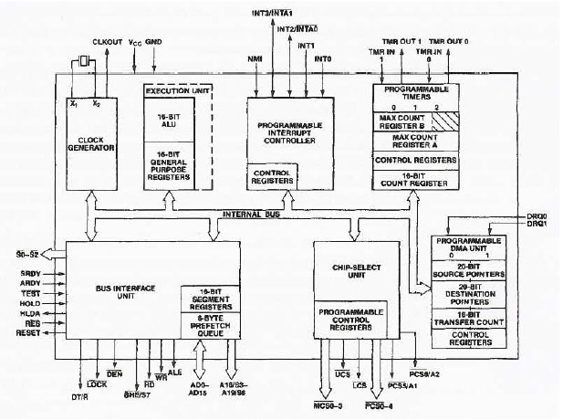

- The Bus Interface Unit (BIU)
- Execution Unit (EU)
- Clock Generator
- Programmable interrupt controller
- Programmable Chip Select Unit (CSU)
- Programmable DMA Unit
- Programmable counter/timers

